

**DAYANANDA SAGAR UNIVERSITY**

**SCHOOL OF ENGINEERING**

**MICROPROCESSOR AND APPLICATION (16CS206)**

**SYNOPSIS/PROJECT REPORT**

***TOPIC: WATER LEVEL CONTROLLER USING 8051 MICROPROCESSOR***

**(2nd YEAR – 4th SEMESTER)**

***TEAM MEMBERS:***

***MUSKAAN SINHA (ENG18CS0178)***

***MUSKAAN GOEL (ENG18CS0177)***

***MEGHNASHREE M (ENG18CS0165)***

***LYSETTI LAKSHMI POOJITHA (ENG18CS0150)***

***LAVANYA S (ENG18CS0149)***

* **TOPICS COVERED IN SYNOPSIS:**

1. **Introduction to the Project**
2. **Principle used for the Project Circuit**
3. **Circuit Diagram**
4. **Components Required for the Project Circuit**
5. **Design & Operation**
6. **Algorithm for the Project**
7. **Advantages**
8. **Applications & Conclusion**
9. **INTRODUCTION TO THE PROJECT**

Water Level Controller using 8051 Microcontroller project will help in automatically controlling the water motor by sensing the water level in a tank. This article explains you how to detect and control the water level in an overhead tank or any other container. This system monitors the water level of the tank and automatically switches ON the motor whenever tank is empty.

The motor is switched OFF when the overhead tank or container is FULL. Here, the water level of the tank is indicated on LCD (Liquid crystal Display). Using this system, we can avoid the overflow of the water.

We are designing the circuit which is used to detect and control the water level automatically in overhead tank using 8051 microcontroller.

In this system, water sensing can be done by using a set of 4 wires, which are placed at different levels in tank. DC supply probe is placed at the base of the tank.

1. **PRINCIPLE USED FOR THE PROJECT CIRCUIT**

This project system mainly works on a principle that “water conducts electricity”. The four wires which are dipped into the tank will indicate the different water levels. Based on the outputs of these wires, microcontroller displays water level on LCD as well as controls the motor.

Initially when the tank is empty, LCD will display the message LOW and motor runs automatically. When water level reaches to half level, now LCD displays HALF and still motor runs.

When the tank is full, LCD displays FULL and motor automatically stops. Again, the motor runs when water level in the tank becomes LOW.

1. **CIRCUIT DIAGRAM**

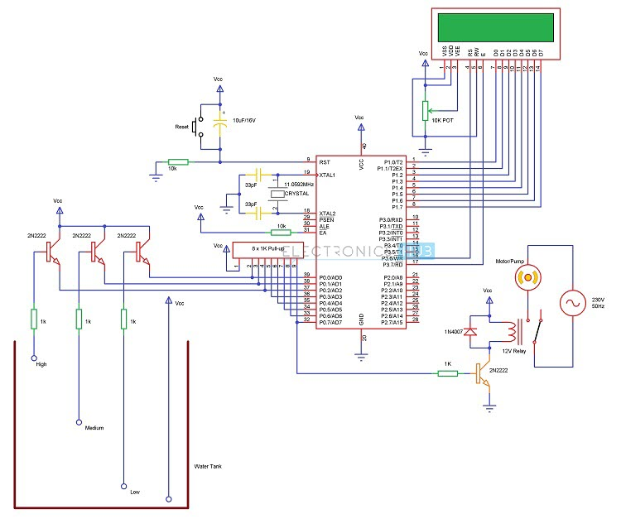

1. **COMPONENTS REQUIRED FOR THE PROJECT**
2. AT89C51 Microcontroller (or any 8051 based Microcontroller)
3. 8051 Programmer (Programming Board)
4. 11.0592 MHz Quartz Crystal
5. 2 x 33pF Capacitor
6. 2 x 10KΩ Resistor (1/4 Watt)
7. 10µF Capacitor
8. Push Button
9. 1KΩ x 8 Resistor Pack (for Pull – up)
10. 16 x 2 LCD Display
11. 5V Relay
12. 4 x 2N2222 (NPN) Transistors
13. DC Motor (for demonstration)
14. 10KΩ Potentiometer
15. 1N4007 PN Junction Diode
16. Programming cable
17. Connecting wires
18. Power Supply
19. Keil µVision IDE
20. Willar Software (for burning code)
21. Proteus (for circuit diagram)
22. **DESIGN & OPERATION**

DESIGN: The heart of the Water Level Controller using 8051 Microcontroller project is the AT89C51 Microcontroller. The water level probes are connected to the P0.0, P0.1 and P0.2 through the transistors (they are connected to the base of the transistors through corresponding current limiting resistors). P0.0 for LOW level, P0.1 for HALF Level and P0.2 for HIGH Level.

The Collector terminals of the Transistors are connected to VCC and the Emitter terminals are connected to PORT0 terminals (P0.0, P0.1 and P0.2).

PORT1 of the microcontroller is connected to the data pins of LCD and the control pins RS, RW and EN of the LCD Display are connected to the P3.6, GND and P3.7 respectively.

OPERATION: Initially, write the program for Water Level Controller in Keil µVision IDE and generate the .hex file.

Burn the program (.hex file) to the microcontroller using external programmer and Willar Software.

Now give the connections as per the circuit diagram.

While giving the connections, make sure that there is no common connection between AC and DC supplies (if you are using an AC Motor)

Place the 4 water level indicating wires into the small tank (3 probes for three different levels and fourth one for common supply)

Switch on the supply. Now, the motor will run automatically as there is no water in the tank. (It will turn on even if the water level is LOW).

Now pour the water, when it reaches LOW level, then LCD displays LOW.

For middle level, it will display as HALF on the LCD.

Still if you pour the water, then the water level reaches full and the LCD displays FULL and also the motor is turned OFF automatically.

Switch off the motor supply and board supply.

1. **ALGORITHM OF THE PROJECT**

* First configure the controller pins P0.0, P0.1 and P0.2 as inputs and P0.7 as output.
* Now, initialize the LCD.
* Continuously check the water level input pins P0.0, P0.1 and P0.2.
* If all the pins are low, then display tank as “EMPTY” on the LCD and make P0.7 pin HIGH to run the motor automatically.
* If the level is low i.e. if P0.0 is HIGH, display the water level as “LOW” and continue to run the motor.
* A HIGH pulse on the pin P0.1 indicates that water has reached half level. So, display the same thing on LCD and run the motor normally.
* If P0.2 is HIGH, then the water level in the tank is FULL.
* Now, make the P0.7 pin as LOW to turn off the motor automatically.

1. **ADVANTAGES**

* Human effort is reduced as the system controls the motor automatically based on the water level.
* This system consumes less power.
* Simple and more reliable.

1. **APPLICATIONS AND CONCLUSION**

* Used in big buildings where the manual monitoring is difficult.
* Used in industries to control the liquid level automatically